**Make a differencE, serve your community**

POLL workers **get paid** and training is provided

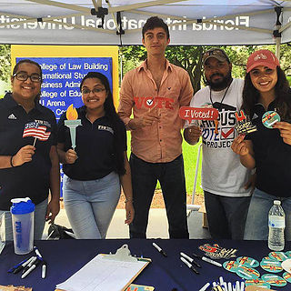**BECOME AN ELECTION WORKER**

Have you ever thought you’d like to serve as an election worker in your community or wondered what it takes to become an election worker?

The election workers are your friends and neighbors who, on Election Day, greet every voter and make sure that every vote counts. As we prepare for our next election, you have an opportunity to participate in the most important responsibility we do in democracy.

Today’s elections blend new technology with personal, hands-on attention to detail. Our election workers love to work with people and find excitement in every election. As an election worker, you will be an essential part of the election process. Each member of the team plays a critical role in ensuring that everyone who is eligible to vote is able to cast a ballot.

Requirements:

* You can be 16 years of age.
* If you are 18 years of age by Election Day, you must be a qualified and [registered](https://www.michigan.gov/sos/0,4670,7-127-1633_11976---,00.html) elector of the State of Michigan.
* You must submit a completed an [application](https://www.michigan.gov/sos/0,4670,7-127-1633_11976---,00.html) to the local clerk.
* You must go through the provided paid training.

Election workers are essential to ensuring that elections are a success. The City of Niles encourages those interested in becoming election workers to learn more about what is required and how to work for the City of Niles, Michigan on Election Day.

Contact the Niles City Clerk’s Office at [cityclerk@nilesmi.org](mailto:cityclerk@nilesmi.org) or (269) 683-4700 x 3030 or 3031 to be an Election Worker. We’d be happy to add you to the **Election Day Team!**

**CITY OF NILES, MICHIGAN**